The Abyss – Design Overview
By Reza Ghassemi
Abyss is a 2D, side-scrolling adventure platformer set in an underground world. The player controls Lund, a dwarf searching for the final component to bring his perfect mate to life. Gameplay consists of navigating the Abyss’s difficult underground terrain and evading its strange hostile denizens using Lund’s greatest skill: the ability to assemble tools from the materials he finds along his way.
Table of Contents:
- The Gameplay
1.1. Basic Interaction
1.2. Playing the Game
1.3. The HUD
1.4. The Inventory
1.5. Combination and Disassembly
1.6. Types of Items
1.7. Using Items
- The Story
1.1. Background
1.2. Prologue
1.3. Chapter One
1.4. Chapter Two
1.5. Chapter Three
The Gameplay:
Abyss is a 2D, side-scrolling, adventure-platformer. Gameplay revolves around acquiring things from the environment, and combining them through an inventory system in different ways in order to build the tools needed traverse the environment and out-maneuver enemies.
Basic Interaction
Lund, the main character, can walk, run, jump, use his currently equipped item, and pick up other items. He can also open up an inventory screen to view information on items he currently possesses, and to combine or disassemble them in different ways to create new items.
Lund can walk forward and backwards along a 2D plane. He standard speed is a relatively fast jog.
Lund can also move away from the camera when passing through a door. This is done through the vertical control button (UP on the D-pad or Joystick).
Lund can jump 1.5 times his height.
Lund can also pick up, equip and use items.
- Picking up items requires moving near an item, then pressing and holding the Pick Up Item key.
- Lund can equip items via either
  - The Inventory screen, by highlighting the item and pressing the equip key. Which button serves as the equip key in the inventory is indicated next to the highlighted item. (see Inventory)
  - The Quick Select keys. There are two quick select keys which simply scroll the currently equipped item in two directions, corresponding to the order in which the items are arranged in the Inventory. Only equipable items (see Types of Items) can be equipped, of course.
- Equipable items may or may not have a use. Some items may even have two uses. The primary use, if it exists, can be accessed via the Main Use Key, and a secondary use, if there is one, can be accessed via the Secondary Use Key. What using an item does depends on the item of course, but in general
  - There are some items that are used automatically when equipped. Eg: Bottle of Sunflies gives off light. Having it equipped will cause it to light the area around Lund. That is its only function.
  - Some items simply play an animation. For example, using the pickaxe just plays a 'Swing the Pickaxe' animation, and breaks anything breakable that is directly in front of Lund, in range of the pickaxe.
  - Some items have to aimed, for example the gun, slingshot, or grappling hook. Using these items switches Lund to Aiming Mode, in which his controls are somewhat different (see next section).
  - Some items are worn, which is different from being equipped in the sense that an many item can be worn, but only one can be equipped at any given time. For example, Lund can wear a Helmet, and then equip something else, and still wear the helmet. To take the helmet off, Lund 'Equips' the item and uses it again.
When equipped with certain items, like a gun, slingshot, or grappling hook, Lund may need to aim. Using such an item causes the player to enter Aiming Mode. In Aiming Mode, Lund can point his equipped item in a 135 degree angle from pointing directly above his head, to pointing at the ground in front of him (not directly between his feat – 135 degree angle). Some items may modify this range. While in Aiming mode Lund cannot move; instead the movement keys adjust where he aims. To use the item (fire the gun, throw the grappling hook) press the use key. Any other button will exit Aiming mode.
Lund also has the ability to engage in dialog with NPCs. Dialog in Abyss is not voiced, and represented in text boxes that appear at the bottom of the screen. If the character Lund is speaking to is an important character, a portrait picture of his face will appear next to his text box. Most dialog just consists of the NPC talking, though Lund will occasionally respond. There is no branching dialog tree system or anything of the sort in Abyss; the player does not control what Lund says.
Playing the Game
The object of the game is determined by the story, but usually it is to get somewhere, which means moving through underground levels and overcoming the obstacles Lund encounters there without running out of health.
Heath is represented as a Health Meter (see HUD) which is a Zelda style heart. When Lund takes damage, he loses a portion of the heart. The minimum damage he can take is ¼ the heart, the maximum is 1 whole heart. In addition, if Lund is wearing (see Basic Interaction) armor (such as a Helmet) at least one icon corresponding to that item will appear next to the heart, and act as an extension of the health gauge. In this way, wearing armor allow Lund to withstand additional damage.
Levels resemble platformer levels, with physical obstacles and enemies that must be defeated a certain way. Obstacles and enemies are overcome usually through the use of a tool which Lund puts together from component pieces he finds in the level. Simpler puzzles may make use of the component pieces themselves.
Obstacles in levels consist largely of Phyiscal Barriers, Mechanical Barriers and Enemies.
Physical Barriers, like a bottomless (or very deep) pit, require Lund to find a way to get past them. In the case of the pit, Lund might be able to jump over it, or use an item to propel himself over it.
Mechanical Barriers are a large item of some sort which needs to be repaired or modified in order for Lund to use it. For example, a damaged rope bridge which needs reinforcement (by combining it with another piece of rope) for Lund to cross it is a mechanical Barrier.
Enemies are creatures which stand in Lund's path. They need to either be defeated or evaded. An example might be a Goblin with a spear standing in Lund's way. Lund can either shoot the Goblin with his gun, if the player has a gun, or he can use his grapping hook to access another path which allows him to evade the goblin.
These descriptions may not categorize every obstacle in the game, but they cover most of them.
It is my intention to design obstacles in Abyss such that there will usually be more than one way around them. I want several solutions for each problem. For example, a difficult jump might be passable by building a trampoline, or by building a grappling hook. In some cases wasting or missing certain materials or combinations might result in parts of the game being inaccessible, but it will always be possible to continue the main story. At worst, wasting a necessary expendable item will require the player to backtrack to pick up another one.
In order to keep number of possible different combinations of inventory items from getting out of control, the player’s inventory will be reset at the beginning of each chapter. Difficulty will increase toward the end of each chapter, and decrease sharply again at the beginning of each new one. Each chapter will be slightly harder than the last.

The HUD
The HUD consists of the main game screen, of a 2d side-scrolling level, overlaid with:
- The Health meter (see Playing the Game), which appears in the upper left hand corner of the screen.
- The Current Item. A box with a an image of the currently equipped item. When the player is using the Quick Select Keys (see Basic Interaction) to change the currently equipped item, two other semi-transparent boxes appear next to the Current Item box, displaying the items available to switch to by scrolling left or right through equipable items.

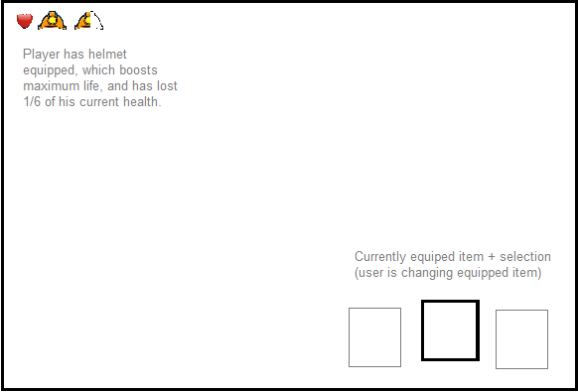
The Heads-Up Display

The Inventory
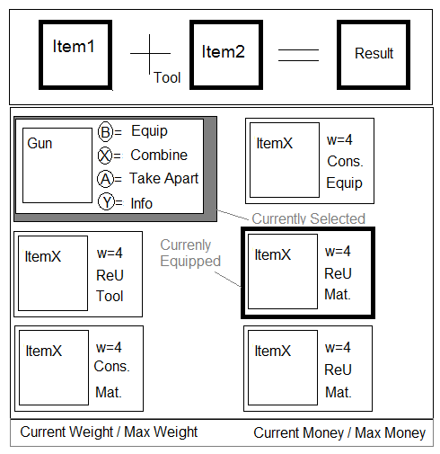
The player navigates the inventory using the directional movement keys (D-pad or Joystick on Xbox). The top pane is a Combination Panel. In order to add items to the Combination Panel (see Combination and Disassembly) in order to perform a combination, the player must select two items from the Main Inventory Panel.
The Main Inventory Panel consists of a list of currently possessed items. Each item's field includes its picture and name, Weight, Reusable vs. Disposable, and Equipable vs. Material vs. Tool.
The currently equipped item is highlighted, and the currently selected item has an expanded field, which lists all the available actions for that item available from the inventory, along with the corresponding button. Available actions are
- Equip: Available if the item is equipable. After equipping Lund will be holding the item, and the player can use it in the main game.
  - For Tools: if the item is a Tool, rather than becoming highlighted as “currently equipped”, it will become the current tool, as indicated by the “+” slot in the Combination Panel (see Combination and Disassembly).
- Unequip: Available if the item is currently equipped. After unequiping, Lund will not have an item in his hand.
- Combine: Add the item to the first free slot in the Combination Panel. Not available for Final Objects.
- Take Apart: Disassemble. Brings up the Disassembly Panel. Destroys the item and return its component pieces. Not available for Basic Components.
- Drop: Removes the item from inventory. That item is gone and cannot be retrieved. Not all items can be dropped.
- Info: Display more detailed info about the item. This includes a description, list of use keys, all info from Main Inv. Panel, and a list of Components. Info appears in a pop-up window. Example pictured below.
- Use: Some items can be used from the inventory itself. This would be equivalent to to using the item if it was equipped from the main game screen.
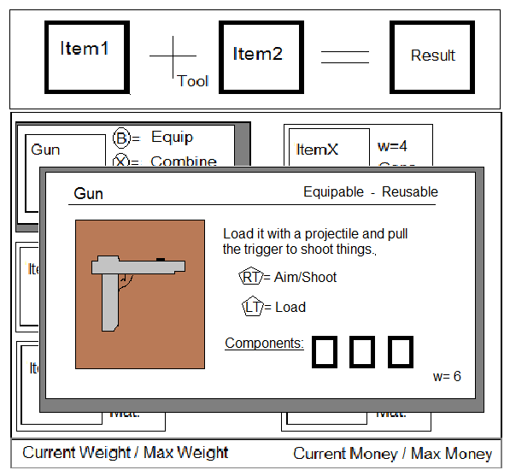
Pictured above: The info pop-up
Combination and Disassembly
As in many adventure games, the player can combine inventory items in The Abyss, in order to create new items. In fact, assembling things from parts is a major part of gameplay. Two items can be selected for combination at once. If the two items are compatible, they will then disappear from the inventory to be replaced by a third item. Items acquired through combination can also be further combined with other items. Combining items represents the act of building a device from parts, eg: building a slingshot from a Y shaped pipe and a rubber band; or supplying ammunition or fuel to an item eg: combining the slingshot with rocks so it shoots rocks, or with hot coals so it shoots hot coals.
Items can be combined and disassembled. Basic Components (see Types of Items) cannot be disassembled. When an item is disassembled, any reusable component items are returned to the inventory. Non-reusable components are destroyed.
Combination is done through the Combination Panel. The Combination Panel is a small window that appears as part of the inventory screen at the top of the menu. It looks roughly like this:
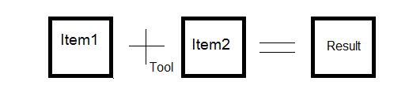
Item 1 and Item 2 are selected from the inventory. When scrolling though the inventory there will be two buttons which allow the player to select an Item for combination. The order of combination never matters.
The tool is by default a regular + sign. This corresponds to a simple combination, eg combine a rope and a hook with the + and Lund will tie the rope to the hook. Highlighting the + and clicking will allow the player to select from a list of tools which can replace the +, for a more specialized combination (see Types of Items). The icon of the selected tool will then appear in subscript beneath the plus, (as in the above diagram), until the player selects a different tool, or sets it back to the simple combination.
The vast majority of combinations in Abyss will be simple combinations.
Combination can also be done outside the Inventory, with certain objects on the map. In this way Lund can repair a damaged bridge or boat. In this case, Item 1 will always be the item Lund interacted with, and selecting Item 2 and Tool will allow Lund to choose the Item and Tool he wishes to use from his Inventory.
When the player selects an item for disassembly, a pop up menu appears indicating which item is about to be lost, and which items are returning to the inventory as a result. This window prompts the player for final confirmation, then disassembles the item.
Types Of Items:
All items are either:
Consumable - or – Reusable
Consumable means the item can only be used in combination once, or equivalently, cannot be retrieved from a combination by disassembly. Reusable means you can combine, disassemble the combination, and recombine as many times as you want.
For example glue is a consumable item, while a pickaxe head is not. You might combine the pickaxe head with a rope to make an makeshift anchor. You then may disassemble your anchor to retrieve the head and glue it to a stick to make a pickaxe. The second combination would consist of combining glue with a stick, and then combining the gluey stick with the pickaxe head. Now, the glue is consumable. So, if you tried to disassemble that pickaxe, or even the gluey stick, you could not retrieve the glue.
Equipable -or- Material -or- Tool
Not all items can be equipped and used outside the inventory system. Many items exist only for the purpose of combination. An item that cannot be equipped is either a Material or a Tool. Materials are used in combinations, in order to eventually produce an equipable item or tool.
For example, the pickaxe, and anchor in the previous example were equipable, while the glue, stick, rope, and gluey stick were material.
An item may also be a Tool, which means it is used as a means of combination, rather than a component in combination. So rather than selecting an item as an ingredient in a combination, the player selects to use the tools with a combination of two items. Tools open up new forms of combination, and help to make the combination interface more precise, so the player knows what he is doing when selecting items for combination.
For example, the first tool the player will acquire is a hammer. The hammer can be used with schematics and metal for various sorts of metal works. Eg, get a schematic for a helmet, then combine the helmet schematic with some iron using the hammer, and get the Iron Helmet.
(Schematics are just another sort of material, specific for use in combinations where some sort of design needs to be specified.)
Basic Component -or- Intermediate Component -or- Final Object
A component is an item which can be used in a combination. For example the pickaxe head, or the glue are components and the pickaxe itself is a Final Object, since it cannot be used in any further combinations (though it can be disassembled).
A component is Basic, if it cannot be disassembled, and its its an Intermediary Component if it can be further combined into another Intermediate Component or Final Object.
It should be noted that:
And item can be both Equipable and either Final or a Component of any kind.
All Tools are Final Objects.
No Consumable items are Final Objects.
These are internal distinctions; the player will never be explicitly told whether an item is a Basic or Intermediate Component, or is a Final Object.
Expendable -or- Unbreakable
Some items can only be used a certain number of times, or for a finite length of time before they are destroyed. For example the Iron Helmet will increase the player's maximum heath by several notches, but once that extra health is lost, the Helmet is destroyed. Torches are also Expendible, they only burn for a set length of time before they are gone.
Any object that is not Expendable, is considered Unbreakable.
Dissembling an Expendable object after it has been partially expended will yield fewer component items. Which component items will disappear depends on the item in question.
This distinction only applies to Equipable items and Tools, it makes no sense in the context of Materials.
** Remember the distinction between Expendable and Consumable: an Expendable item is an Equipable item or Tool which can be used up, while a Consumable Item cannot be retrieved from a combination.
In order to safeguard against the try-all-possible-combinations adventure game strategy, most items will require using expendable parts. This means that the number of combinations the player can try will be limited by his supply of the expendable items in question. The burden is on the level design to ensure that the player never finds himself in a position where an erroneous combination destroys an expendable item he needs in order to continue the game.
Using Items:
Most items can be used by pressing the “Use” key once they are equipped. Some items are tools and can be used anywhere, others are special purpose and might need to be used in a particular location. For example, Lund can use his pickaxe at any point in the game, but a lock pick can only be used on a door. Because there are a wide variety of items available, some may require the use key to work differently, or even need more than one button. In this case instructions on how to use the item will be given on its info page in the Inventory (see Inventory).

The Story:
Background:
Dwarves live underground, and are all about building things. They are technical geniuses, and are capable of building a variety of mechanical wonders even with the limited materials available to them in the subterranean world of Abyss. They even know how to create living things. In fact, their reproduction as a species is based on this ability. All Dwarves are born male, with a notion of what their ideal women would be like. The male Dwarf works his whole life to become a skilled craftsman, and serves his society in the hopes that he will be granted the right to build his perfect mate. If a dwarf proves himself worthy to his society, he is given the materials necessary to do this. The moment he brings his greatest creation to life is the pinnacle of a male dwarf’s existence. The women however, once brought to life are fully independent individuals, and choose whether or not they wish to stay with their creator and have children. Since the woman came from the mind of the man, it is considered a sign of mental imbalance or disease in the man if she chooses to leave him. The male will not get a second chance.
The dwarves share Abyss with several other types of creatures, some intelligent and some not, some friendly and some hostile. The dwarves most hated and dangerous enemies are the goblins.
Dwarves create and preserve things, and in dwarven culture, destruction, waste, and killing are considered the highest sins. Dwarves kill only in self-defense, and most dwarves hate doing it even then. Goblins, then, are the antithesis of dwarves. They are a nomadic race of xenophobic consumers. They move from place to place in large groups and use up resources in an area before they must move on. They hate everything non-goblin, and will usually seek to destroy all life in their path. They are intelligent and clever, but their technology is primitive, mostly stolen from other species. They especially hate the dwarves, and take a special pleasure in killing them and destroying the things they’ve built. No one knows how the goblins reproduce, but it is theorized that they do so prolifically, since there are usually many of them, and they persist in the Abyss despite being enemies of everything else that lives there.
The limiting factor in the dwarves’ ability to create life is their supply of Ember. Ember is a fruit born by a very difficult to cultivate plant. It is needed to “power” a living being, and can only be used once. The dwarf community grows the largest quantities of the plant that they can, but supplies are still limited. When a male dwarf has reached maturity and earned the right to bring his perfect mate to life, he is given a single Ember. Ember is considered to be the source of all life in the Abyss, in some form or other. The other creatures aside from dwarves have different ways of interacting with the plant. Most simply grow it within their bodies. Goblins are the only known species that don’t seem to require the fruit to exist. This fact leads many dwarves to believe that they are not truly alive, and is the basis for the relaxing of dwarven rules about killing as regards goblins. Destroying Ember, either by killing another living creature in cold-blood, or by destroying the fruit itself, is the greatest crime one can commit in the eyes of the dwarves. This should not come as a surprise, since their very existence depends on the fruit.

Prologue:
The protagonist of this game is Lund, an ordinary dwarf living in the dwarf city. Lund reached maturity some time ago, but has yet to prove himself worthy of being granted an ember to bring his mate, Lin, to life. The Ember is the last piece he needs. He is skilled at building things, like all dwarves, but does not excel in any particular area. He has not invented anything useful, nor done any great deeds worthy of earning him the recognition of the Council of Elders which governs the dwarf city and regulates the Ember supply. He is getting old, and beginning to despair that he will ever be given a chance to fulfill his life’s dream.
One night Lund dreams that a voice is calling him from a distant and dangerous part of the Abyss, known as the Garden. It’s the voice of his imagined mate, Lin. He sees a vision of a solitary Ember plant in the dark underground -- and of the path he must traverse to reach it. He wakes up, convinced that the dream is real, and decides to set off for the Garden to find the Ember and bring his beloved to life.
Chapter One: The Garden
Lund leaves the dwarf city and journeys into the depths of the Abyss in the hopes of finding the Ember plant. On the way, he passes through a small settlement known as the Intersection and meets a being called the Tall One, who helps him along his way. Along the way, he encounters goblins, which seem to be searching for the Garden as well.
Chapter Two: The Stairs
Once awakened, Lund’s new mate is summoned by a mysterious power, and slips away in the night. Lund can’t believe she chose to leave him, and so he follows her. This is a violation of dwarf law; by chasing her, he risks exile. Lund pursues Lin to The Intersection where he learns that she has left for the Stair, a dangerous road to the surface of the Abyss, from which no one has ever returned. The Tall One warns him against going that way but when Lund refuses to listen, he gives him the equipment he needs to climb the Stair. Lund reaches the top, only to discover that he has stumbled into the goblin’s home base, and is captured.
Chapter Three: The City
The goblins home base is a sunken, futuristic human city destroyed a long time ago. Lund sees for the first time the goblin leader, a giant, immobile metal monster which seems to have the power to create goblins. He escapes the goblins and frees Lin, who was captured as well, and they seek refuge with the Outcast, an old human living hidden away in the ruins. Here they learn that the piece of Ember inside Lin is a unique form of the plant, and can be reused multiple times. It also possesses a very low-level consciousness of its own. There are only two like it, and the other is what powers the Metal Giant. The giant is after Lin’s Ember, because he needs it to regain his mobility and full destructive power. That’s why the goblins were in the Garden. When it realized it might be found, it called to Lund to keep itself safe. It guided Lin here to free its twin and kill the monster. Lin knows she cannot do this however, and so she is prepared to destroy herself to prevent the giant from getting the Ember. Lund convinces her not to and volunteers to destroy the thing himself. He manages to destroy the monster, but only by destroying the twin Ember inside it. Destroying an Ember means he can never return to the dwarf city, but he has won Lin over at least, once and for all.
Though it is never explicitly stated, Abyss is what is left of Earth, after humanity has destroyed it. The Embers and the technology to create life were invented by humans, who seem to have used them to create destructive life forms, which have mostly destroyed the world. The dwarves and other creatures of Abyss were also created by humans. The Tall One and the Outcast are the only surviving humans in this part of the world.

